Inquiry Project 6: Area Model Multiplication

Part 1: Discovering an Area Model
 | Online Activity  Access the interactive simulator to begin this project. | 
In this activity, whenever you see 💬, stop and share your responses with your partner. If you have different responses, try to come to a consensus.
Today you are going to investigate something called an interactive simulation. It is a tool that will help you visualize how area model multiplication works.
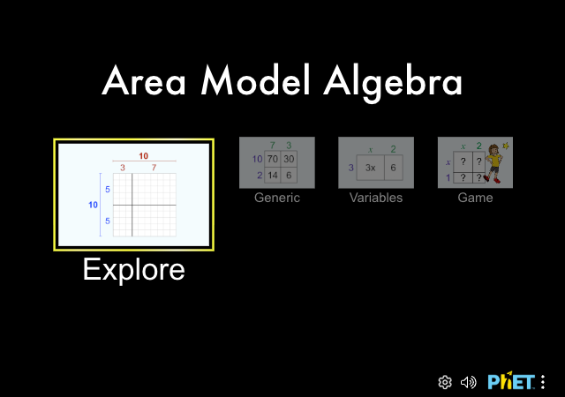
Step 1 - Open the interactive simulator, Area Model Algebra in your web browser. You will use it to complete this project. It will look like the image above.
Step 2 - Play with any of the screens on Area Model Algebra for 5 minutes.
Step 3 - Complete the following questions.
- What does the area of a rectangle have to do with multiplication?
- Write down two things you notice or have questions about, and one thing a neighbor noticed that is interesting to you.

Part 2: Understanding an Area Model
In this activity, whenever you see 💬, stop and share your responses with your partner. If you have different responses, try to come to a consensus.
For questions 1-8, use the following instructions.
Use the simulation screen labeled “Explore”. Note you can switch between simulation screens using the toolbar located below the area model.

- Explain what the red and blue sliders do to the outside of the rectangle.
- Explain what the red and blue sliders do to the inside of the rectangle.
- Describe what changes and what doesn’t change when the red and blue sliders are moved. 💬
- Multiply $10×15$ using an area model. Find two different ways to partition the $10×15$ rectangle. Use the sim to support you in filling out this table. 💬
Problem | Area Model | Partial Products (Sum) | Total Area
$$10×15$$ | 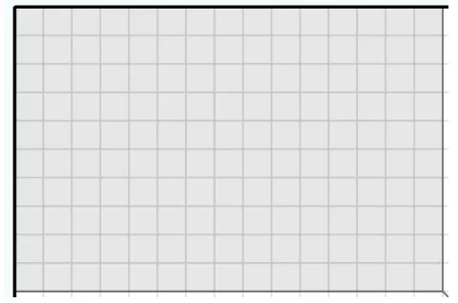
$$10×15$$ | 
- Use the sim to model $6×18$. What is the total area of this rectangle? Represent the total area in multiple ways.
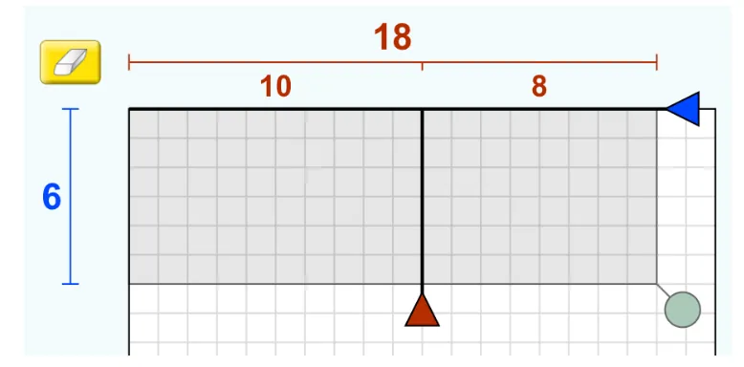
- In an area model, how do the partial products (interior numbers) get calculated?
- In an area model, what are two different ways the total area could get calculated?
- How do the partial products relate to the total area of the area model?

Part 3: Using an Area Model
In this activity, whenever you see 💬, stop and share your responses with your partner. If you have different responses, try to come to a consensus.
For questions 1-4, use the following prompt and instructions.
Suppose we want to find the product of 17 and 13 using an area model. Use the simulation screens labeled “Explore” and “Generic”. Note you can switch between using the toolbar located below the area model.

- Draw and label your partitions on the scaled area model below.
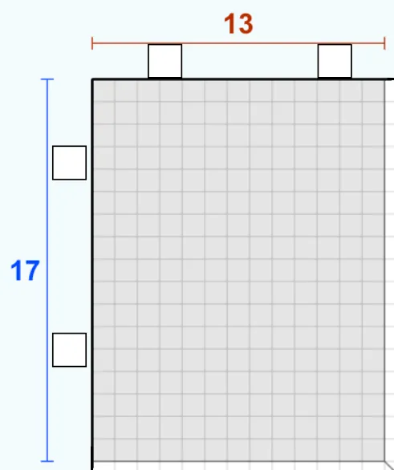
- Draw and label your partitions on the generic model below.
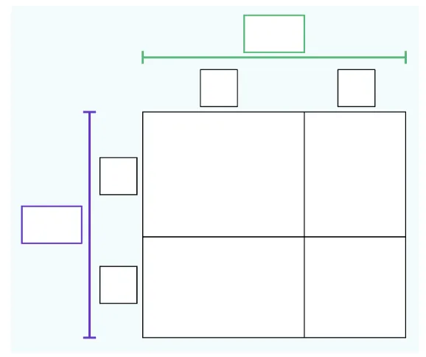
- Discuss with your group: How does your area model compare to those in your group? What is the same? What is different? 💬
- Justify how you know your model represents 17x13. Does your area model represent 17✕13? How do you know? 💬
- Challenge yourself to work through levels 1-2 of the Area Model Numbers Game!
- What are three different ways you could partition 17?
- Write your own 2-digit times 2-digit multiplication problem that uses an area model, and find the total area.
- What is a convenient way to break up a multiplication problem into an area model, and why is it convenient for you?

Part 4: Applying an Area Model to Polynomials
In this activity, whenever you see 💬, stop and share your responses with your partner. If you have different responses, try to come to a consensus.
For questions 1-3, use the following instructions.
Use the simulation screen labeled “Variables”. Note you can switch between simulation screens using the toolbar located below the area model.

- Play around with entering your own variable expressions, then answer the following:
  - In an area model, how do the partial products (interior numbers) get calculated?
  - In an area model, how does the total area get calculated?
  - How do the partial products relate to the total area of the area model?
- Use the sim to model $6(x+8)$. What is the total area of this rectangle? Represent the total area in multiple ways. 💬
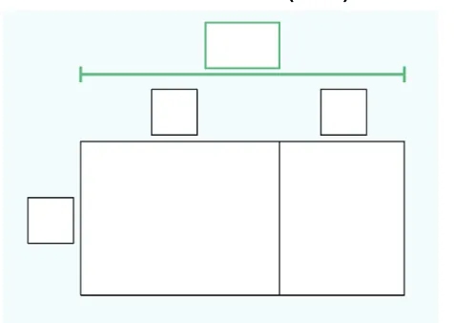
- Use the sim to model $(x+3)(x-5)$. What is the total area of this rectangle? Represent the total area in multiple ways. 💬
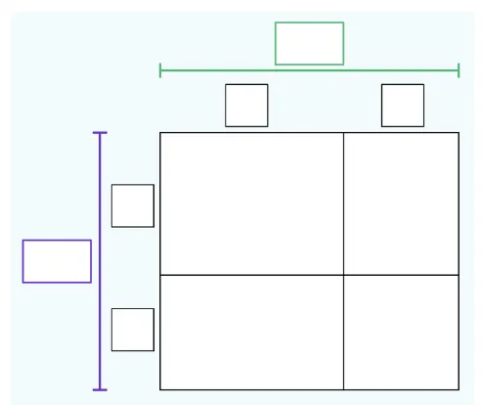
- Challenge yourself to work through levels 1 - 4 of the Area Model Numbers Game!
- How is multiplying variable expressions using an area model similar to multiplying numbers using an area model?

Extension
Challenge yourself to work backwards and factor and algebraic expression!
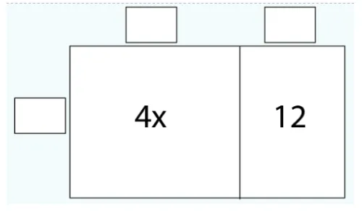
The Area Model sim is playing tricks on you! It gives you the partial products, but not the side lengths. What numbers and/or variables must be on the outside of this rectangle?

